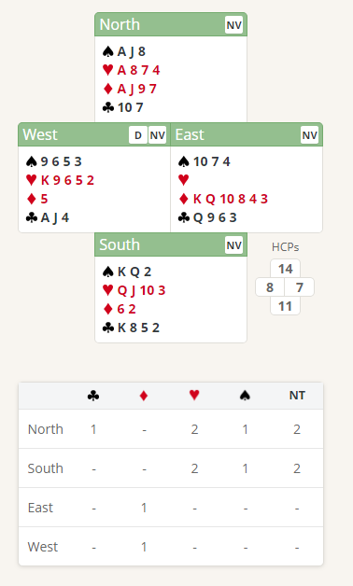
Thursday Bidding Tips 2 Board 8 played on 26/4/2018 Hamilton Williams Individual
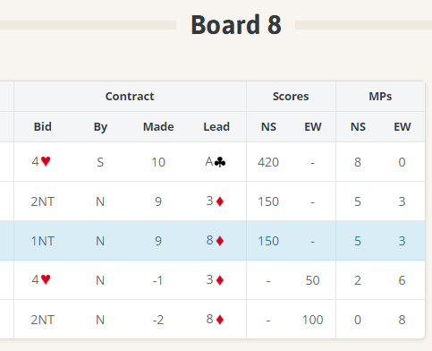

In this board it is difficult to play and make the game contract but it should still be bid. A mistake in the defence may allow the contract to be made. If everybody bids and goes light, there is no damage. The important thing is that game points are there, and the hand should be bid to game.

Suggested Bidding 1 Non Stayman Players
N | E | S | W Dealer
1NT | Pass | 2NT | Pass
3NT | Pass | Pass | Pass

- Norths bid of 1 No Trump shows 12-14 points and at a Balanced Hand.
- Souths reply of 2 No Trump shows 11-12 points and a balanced hand
- North with 14 points now knows that there is at least 25 points, so game is on so bids 3 No Trumps
- South now passes, and North plays it in 3 NT
Suggested Bidding 2 Stayman Players
N | E | S | W Dealer
1NT | Pass | 2C | Pass
2H | Pass | 3H | Pass
4H | Pass | Pass | Pass
Suggested Lead from East King Diamonds (promises at least the Queen). A low diamond lead should be the 8 and will allow North to win the trick with the 9 (a cheap trick) KD Lead may also make it harder for the 3 NT contract to make

- Norths bid of 1 No Trump shows 12-14 points and at a Balanced Hand.
- Souths reply of 2 Clubs shows 11+ points and a 4 card Major
- North with 14 points now knows that there is at least 25 points, so game is on so bids 2 Hearts to show the 4 card Heart suit
- South with 11 points now bids 3 Hearts to show an 8-card fit in Hearts and asking if North is at the top of the 12-14 range
- North has 14 Points so bids 4 Hearts
Suggested Lead from East King Diamonds (promises at least the Queen). A low diamond lead should be the 8 and will allow North to win the trick with the 9 (a cheap trick). The 5 Hearts in West’s hand make it more likely that 4 Hearts will not make

